BUSINESS BLUEPRINT

Document information
Project Name | Software Defect Registration and Resolution Tracking in SAP
Module | CA – Cross Application / Defect Lifecycle Management
Created by | GSU26SAP12
Version | 1.0
Date | 20/6/2026

Change history
Changed date | Items have been changed | Changed content/Reason | Updated by | Type  (A/C/D) | Version
01/06/2026 | Document structure | Create initial Blueprint template for SAP Defect Management System | Bùi Quang Tuấn | A | 0.1
10/06/2026 | Overview / Glossary | Add project glossary and flowchart shape definitions | Phạm Thị Minh Ánh | C | 0.2
18/06/2026 | Organizational Structure | Add role structure for Tester, Developer, and Manager | Nguyễn Tiến Dũng | C | 0.3
25/06/2026 | Business Process | Add DM-01 Defect Lifecycle Management process flow and description | Bùi Quang Tuấn | C | 0.4
02/07/2026 | Reports | Add management reports and dashboard KPI list | Phạm Thị Minh Ánh | C | 0.5
09/07/2026 | All sections | Finalize Blueprint content based on implemented system | Project Team | C | 1.0

Legend: A – Create | C – Change | D – Delete

Advisor Signature
 | Full name & Role | Signature | Date | Note
Created by
Reviewed by

Approved by

FU Signature
 | Full name & Role | Signature | Date | Note
Reviewed by
Approved by

Table of Contents

OVERVIEW

Generated Content - SAP Defect Management System
SAP Defect Management System is a custom SAP Fiori application for managing defect tickets across SAP functional modules FI, MM, SD, HCM, PP and QM. The frontend is built with SAPUI5 1.120+ and TypeScript using the MVC pattern. The backend is implemented with ABAP RAP, CDS View Entities, OData V4 service exposure and custom transparent Z tables. The system standardizes defect creation, developer assignment, lifecycle processing, audit logging, comments, attachments, worklists and KPI reporting.

Architecture & Screen Flow
Login: Simulated role login for TESTER, DEVELOPER and MANAGER; persists userModel/userRole in sessionStorage.
IssueList: Master issue list from /Issue with search by title/module, module filter and ActionSheet sorting.
CreateIssue: Ticket creation form with title, description, module, severity, affected version, due date and developer dropdown.
IssueDetail: Object page containing general data, assignment, version/SLA, resolution, attachments, comments, audit history and RAP lifecycle actions.
DeveloperWorklist: Developer queue filtered by assigned_to current user and status ASSIGNED/IN_PROGRESS/REOPEN.
TesterWorklist: Tester workspace for own tickets and tickets requiring verification in RESOLVED/TESTING.
Dashboard: Manager KPI dashboard with open, overdue, critical, status/severity/module distribution, SLA, MTTR, reopen rate and workload metrics.
Navigation summary: Login -> IssueList -> IssueDetail/CreateIssue/Dashboard/DeveloperWorklist/TesterWorklist. IssueDetail is the central workflow screen for RAP lifecycle actions.

Role Matrix
The authorization design is aligned with backend object Z_BTTICKET_ACT and UI role visibility rules.

OData & Data Model
Main persistence tables:
zissue: Main defect ticket table with lifecycle/status, assignment, version and resolution fields.
zcomment: Comments attached to an issue.
zattachments: Attachment metadata/content for issue files.
zissue_history: Audit log table tracking status and important field changes.
zdeveloper: Developer assignment master data by module and workload_score.

RAP Lifecycle Actions
assignIssue: Assign/reassign developer, typically REOPEN -> ASSIGNED.
startProgress: Developer accepts work: ASSIGNED -> IN_PROGRESS.
resolveIssue: Developer resolves with root_cause and fix_description: IN_PROGRESS -> RESOLVED.
startTesting: Tester starts verification: RESOLVED -> TESTING.
closeIssue: Tester closes verified issue: TESTING -> CLOSED.
reopenIssue: Tester reopens failed fix: RESOLVED/TESTING/CLOSED -> REOPEN.
Entity Set | Source CDS |  | Purpose
Issue | Z_I_ISSUE |  | Main defect ticket entity; supports GET/POST/PATCH/DELETE and lifecycle bound actions.
Attachment | Z_I_ATTACHMENT |  | Issue attachment metadata/content.
Comment | Z_I_COMMENT |  | Issue comments and notes.
History | Z_I_ISSUE_HISTORY |  | Audit trail for status/field changes.
Developer | Z_I_DEVELOPER |  | Developer-module assignment and workload lookup.
Role |  | Responsibilities / Permissions
TESTER |  | Create ticket, upload attachment, start testing, close ticket, reopen ticket, view Tester Worklist.
DEVELOPER |  | View My Work, start progress, provide root cause/fix description and resolve ticket.
MANAGER |  | Monitor all tickets, view dashboard KPIs, assign/reassign developer and supervise workload.

Glossary
Term | Definition | Term
Defect / Issue / Ticket | A recorded problem related to SAP functional modules that needs to be tracked, assigned, fixed, verified, and closed. | Defect / Issue / Ticket
SAP Defect Management System | A SAP Fiori application used to manage the full defect lifecycle for modules FI, MM, SD, HCM, PP, and QM. | SAP Defect Management System
SAPUI5 | SAP User Interface Development Toolkit for HTML5 used to build the frontend application. | SAPUI5
Fiori | SAP design system and user experience standard applied in the application screens. | Fiori
RAP | RESTful ABAP Programming Model used to implement the backend business object and OData service. | RAP
CDS View Entity | Core Data Services model used to expose database data as OData entities. | CDS View Entity
OData V4 | Open Data Protocol Version 4 used for frontend–backend communication. | OData V4
Entity Set | A collection of business entities exposed by the OData service, such as Issue, Comment, Attachment, History, and Developer. | Entity Set
Bound Action | An OData/RAP action executed on a specific ticket instance, such as startProgress or resolveIssue. | Bound Action
Role Matrix | The mapping of allowed functions for Tester, Developer, and Manager. | Role Matrix
Worklist | A filtered list of tickets relevant to a specific role. | Worklist
Dashboard | A management monitoring screen showing KPI metrics such as open tickets, overdue tickets, critical tickets, SLA, MTTR, and workload. | Dashboard
SLA | Service Level Agreement used to measure response/resolution performance by severity. | SLA
KPI | Key Performance Indicator used for management reporting. | KPI
MTTR | Mean Time To Resolve. | MTTR
Audit History | Historical records of status and important field changes of a ticket. | Audit History
Assignment | The process of allocating a ticket to a developer. | Assignment
Reopen | The process of reactivating a ticket when the fix is not successful. | Reopen
Z Table | Custom SAP transparent table in the customer namespace, for example zissue, zcomment, zattachments, zissue_history, and zdeveloper. | Z Table

Flow chart shapes usage
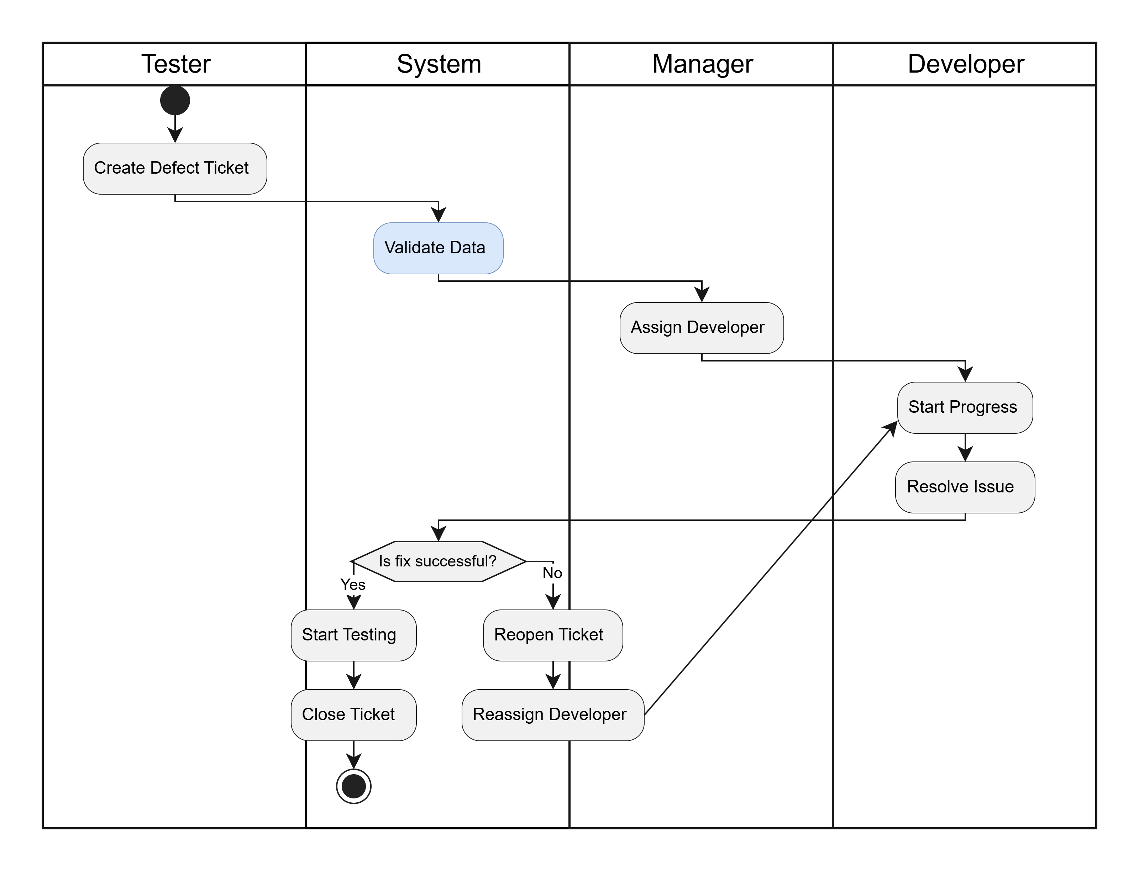

ORGANIZATIONAL STRUCTURE
The organizational structure of the SAP Defect Management System is based on three main business roles. Each role has clear responsibilities in the defect lifecycle.

1. Organizational roles
Role | Responsibility
Tester | Creates defect tickets, verifies fixed issues, closes tickets, or reopens failed fixes.
Developer | Receives assigned tickets, analyzes root cause, implements the fix, and resolves tickets.
Manager | Monitors all tickets, reviews KPI dashboard, and assigns or reassigns developers.
System | Executes automatic validation, developer selection, status update, and audit history writing.
- Organizational structure diagram
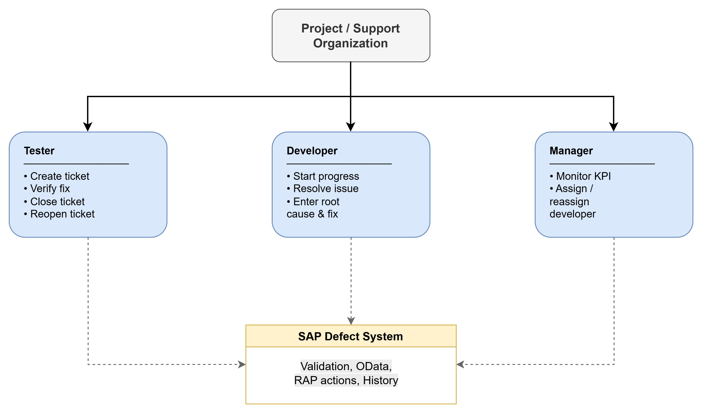

3. Role matrix summary
Function | Tester | Developer | Manager
Create defect ticket | Yes | No | Yes
View issue list | Yes | Yes | Yes
Start progress | No | Yes | No
Resolve issue | No | Yes | No
Start testing | Yes | No | No
Close issue | Yes | No | No
Reopen issue | Yes | No | No
Assign / reassign developer | No | No | Yes
View dashboard | No | No | Yes
View history | Yes | Yes | Yes

BUSINESS PROCESS

SD-MD-01 Customer Master Data
DM-01 Defect Lifecycle Management
Process objective
To standardize the end-to-end process of creating, assigning, fixing, verifying, closing, and reopening SAP defect tickets across modules FI, MM, SD, HCM, PP, and QM.
Process scope
- Ticket creation by Tester
- Developer assignment by system or Manager
- Defect processing and resolution by Developer
- Verification and closure by Tester
- Reopen and reassignment when the fix is unsuccessful
- Management monitoring through dashboard
Out of scope
- Email-to-ticket
- AI suggestion
- Jira / Selenium integration
- Background SLA escalation job

Process Flow
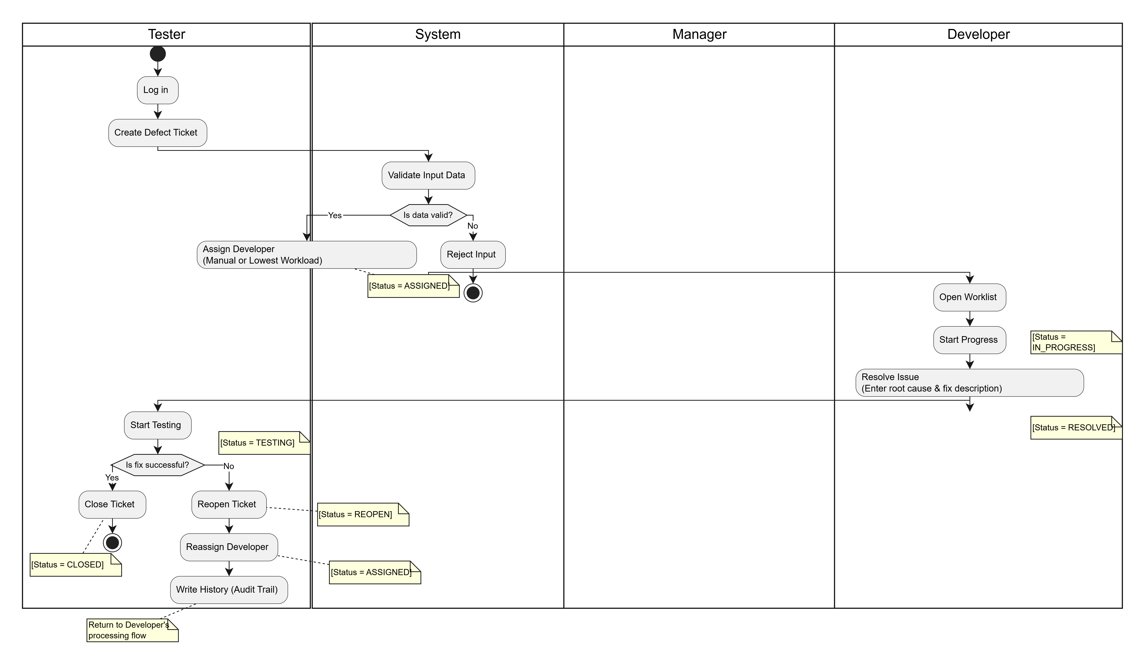

Process Description
Step # | Step Name | Detailed Description | Role
1. | Ticket creation | Identifies a defect in SAP functional modules (FI, MM, SD, HCM, PP, QM) and creates a ticket in the Fiori application. Inputs fields: Title, Description, Module, Severity, Affected version, Due date, Optional developer/attachment. The system validates mandatory fields, future due date, and developer activity/module support. If unassigned, the system auto-assigns the active developer with the lowest workload score. Ticket is stored in zissue with initial status ASSIGNED. | Tester / System
2. | Developer processing | Opens the ticket from the Developer Worklist. Executes startProgress action (status changes to IN_PROGRESS). After analyzing and fixing the issue, executes resolveIssue and enters: Root cause, Fix description, and Optional resolution note. The system updates status to RESOLVED and may calculate the fix version. | Developer / System
3. | Tester verification | Opens the resolved ticket and starts testing (status changes to TESTING).- If successful: Closes the ticket (status becomes CLOSED).- If not successful: Reopens the ticket with a reopen reason (status becomes REOPEN, and reopen count increases). | Tester
4. | Manager monitoring & reassignment | Monitors all tickets through the Issue List and Dashboard. When a ticket is reopened or needs redistribution, the Manager reassigns it to another valid developer using assignIssue. The ticket returns to ASSIGNED status. | Manager
5. | Audit and reporting | Throughout the process, important status and field changes are automatically written into zissue_history. Comments and attachments are maintained for collaboration and evidence tracking. | System / All Roles

4.REPORTS
Based on local requirement, following are reports that can use in the future
No. | Description | T-Code
1 | Activate Dictionary Objects (Z tables, Domains, Data Elements) | SE11 / ADT
2 | Create and maintain CDS View Entities | ADT / SE11
3 | Define RAP Behavior Definition and Behavior Pool | ADT / SE11
4 | Maintain Service Definition for OData V4 exposure | ADT / SE11
5 | Publish Service Binding and activate OData V4 service | /IWFND/MAINT_SERVICE
6 | Maintain authorization object Z_BTTICKET_ACT | SU21
7 | Assign roles TESTER, DEVELOPER, MANAGER to users | PFCG
8 | Maintain developer master data in zdeveloper table | SE16N / SM30
9 | Test OData service endpoint and entity sets | /IWFND/MAINT_SERVICE
10 | Monitor system logs and runtime errors | ST22 / SLG1

Current system support
In the current project scope, the Manager Dashboard already provides KPI monitoring for:
- Total open tickets
- Overdue tickets
- Critical tickets
- Status distribution
- Severity distribution
- Module distribution
- SLA compliance
- MTTR
- Reopen rate
- Developer workload
Future report enhancement
In later phases, these reports can be improved by:
- Server-side analytical CDS views
- Export to Excel / PDF
- Scheduled report generation
- Email notification for overdue or critical tickets
- SLA escalation report

